Website Planning Analysis Sheet

# 1. Project Overview

|  |  |
| --- | --- |
| **Project Name** | Fantasy Rugby Website |
| **Website Goal** | The goal of the website is to demonstrate how I have applied all the concepts, models, tools and practices I have learned in Module 1: Web Design through the creation and hosting of a small ‘front door’ website for a fantasy rugby product. The website will include a landing page, with a login and sign-up CTA and navigation to news, fixtures, league tables and videos. In doing so, it will demonstrate how I have achieved the learning outcomes of designing a website using design approaches such as wireframing before applying that design and layout using HTML and CSS, creating tables and ensuring each webpage is mobile and desktop responsive. |

# 2. Site Map

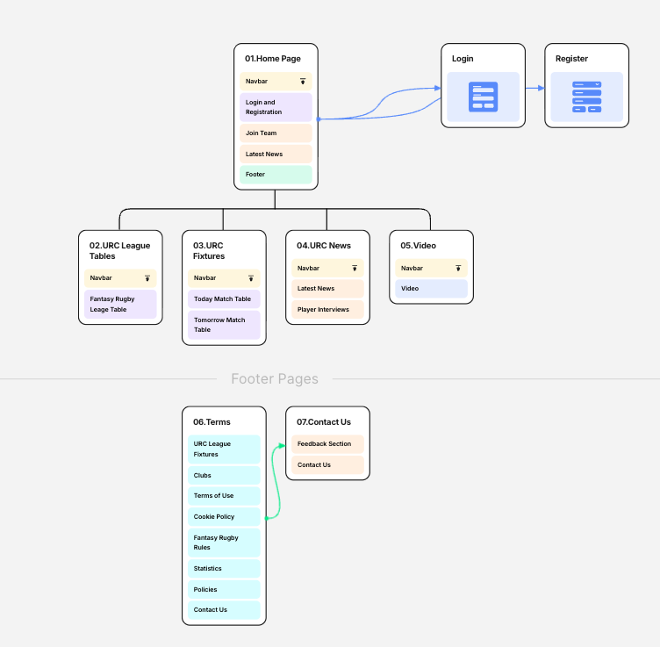

# 3. Content & Information Architecture

|  |  |  |  |
| --- | --- | --- | --- |
| **Page Title** | **Page Element** | **Purpose** | **Required information & Source** |
| 01.Home | Top bar | Introduce branding and URC fantasy rugby title. | Text, URC logo image:  https://people.ey.com/:i:/r/personal/richard_glynn_ie_ey_com/Documents/Documents/UCD/Module%201/00_ASSESSMENT/Assignment%201/Assets/urc-logo.png?csf=1&web=1&e=MJ5vg5 |
|  | Navigation | Navigation orientation for website containing 4 internal links (buttons): URC League Tables, URC Fixtures, News, Videos | CTA text:   1. URC League Tables 2. URC Fixtures 3. URC News 4. Video |
|  | Login & Registration | Call to action enticing users to sign up to the fantasy rugby league or login in to check how they are performing. | CTA Text:   1. Sign up to URC fantasy rugby league   Image:   1. Hero Image:   /Documents/UCD/Module%201/00_ASSESSMENT/Assignment%201/Assets/FloRugby_URC_16x9_Hero.png?csf=1&web=1&e=qvwska |
|  | Join League CTA | Information for users on the steps they can take to create a Fantasy Rugby team and take part. | 3 explainer cards:   1. Text & Image: Join Now /Documents/UCD/Module%201/00_ASSESSMENT/Assignment%201/Assets/FloRugby_URC_16x9_Hero.png?csf=1&web=1&e=qvwska 2. Text & Image: Create League   https://people.ey.com/:i:/r/personal/richard_glynn_ie_ey_com/Documents/Documents/UCD/Module%201/00_ASSESSMENT/Assignment%201/Assets/03.create_and_join_league.png?csf=1&web=1&e=arYXcH   1. Text & Image: Play Now & Challenge friends   Documents/Documents/UCD/Module%201/00_ASSESSMENT/Assignment%201/Assets/04.compete_against_friends.jpeg?csf=1&web=1&e=pZyPaD |
|  | Latest News | Highlights of the latest URC news for the user to quickly see from the home page. | 3 interactive cards:   1. Text & Image: Highlights for the opening weekend   /Documents/UCD/Module%201/00_ASSESSMENT/Assignment%201/Assets/05.opening_weekend.jpg?csf=1&web=1&e=lmzj6V   1. Text & Image: Latest news 2   /Documents/Documents/UCD/Module%201/00_ASSESSMENT/Assignment%201/Assets/07.latest_news_1.jpeg?csf=1&web=1&e=5x0Xwf   1. Text & Image: Latest news 3   /Documents/UCD/Module%201/00_ASSESSMENT/Assignment%201/Assets/08.latest_news_2.jpeg?csf=1&web=1&e=aCcySg |
|  | Footer | List of important links related to URC league and Fantasy Rugby for users to easily access. Also provides a contact us link to a contact us form. | 8 Links (text):   1. URC League Fixtures 2. Fantasy Rugby Rules 3. Clubs 4. Contact Us 5. Terms of Use 6. Statistics 7. Cookie Policy 8. Policies |

|  |  |  |  |
| --- | --- | --- | --- |
| **Page Title** | **Page Element** | **Purpose** | **Required information & Source** |
| 02.URC League Tables | Top bar | Introduce branding and URC fantasy rugby title. | Text, URC logo image:  https://people.ey.com/:i:/r/personal/richard_glynn_ie_ey_com/Documents/Documents/UCD/Module%201/00_ASSESSMENT/Assignment%201/Assets/urc-logo.png?csf=1&web=1&e=MJ5vg5 |
|  | Navigation | Navigation orientation for website containing 4 internal links (buttons): URC League Tables, URC Fixtures, News, Videos | CTA text:   1. URC League Tables 2. URC Fixtures 3. URC News 4. Video |
|  | Fantasy League Table | Table showing the latest league table for the top league in the fantasy rugby league. There is a dropdown filter for selecting your own league to view. | Table:   1. 3 Columns: Position, Team Name and Team Score. 2. 10 Rows for each team in the league sorted from highest to the lowest. |
|  | Footer | List of important links related to URC league and Fantasy Rugby for users to easily access. Also provides a contact us link to a contact us form. | 8 Links (text):   1. URC League Fixtures 2. Fantasy Rugby Rules 3. Clubs 4. Contact Us 5. Terms of Use 6. Statistics 7. Cookie Policy 8. Policies |

|  |  |  |  |
| --- | --- | --- | --- |
| **Page Title** | **Page Element** | **Purpose** | **Required information & Source** |
| 03.URC Fixtures | Top bar | Introduce branding and URC fantasy rugby title. | Text, URC logo image:  https://people.ey.com/:i:/r/personal/richard_glynn_ie_ey_com/Documents/Documents/UCD/Module%201/00_ASSESSMENT/Assignment%201/Assets/urc-logo.png?csf=1&web=1&e=MJ5vg5 |
|  | Navigation | Navigation orientation for website containing 4 internal links (buttons): URC League Tables, URC Fixtures, News, Videos | CTA text:   1. URC League Tables 2. URC Fixtures 3. URC News 4. Video |
|  | Today Table | Table showing the Saturday match fixtures for the new URC rugby games | Table:   1. 3 Columns: Position, Team Name and Team Score. 2. 10 Rows for each team in the league sorted from highest to the lowest. |
|  | Tomorrow Table | Table showing the Sunday match fixtures for the new URC rugby games | Table:  3 columns. Team X vs Team y, kick off time |
|  | Footer | List of important links related to URC league and Fantasy Rugby for users to easily access. Also provides a contact us link to a contact us form. | 8 Links (text):   1. URC League Fixtures 2. Fantasy Rugby Rules 3. Clubs 4. Contact Us 5. Terms of Use 6. Statistics 7. Cookie Policy 8. Policies |

|  |  |  |  |
| --- | --- | --- | --- |
| **Page Title** | **Page Element** | **Purpose** | **Required information** |
| 04.URC News | Top bar | Introduce branding and URC fantasy rugby title. | Text, URC logo image |
|  | Navigation | Navigation orientation for website containing 4 internal links (buttons): URC League Tables, URC Fixtures, News, Videos | CTA text:   1. URC League Tables 2. URC Fixtures 3. URC News 4. Video |
|  | Latest News | Highlights of the latest URC news for the user to quickly see from the home page. | 1. 3 interactive cards: |
|  | Player Interviews | Links to interviews with league players. | 1. 1.     Text & Image: Highlights for the opening weekend. |
|  | Footer | List of important links related to URC league and Fantasy Rugby for users to easily access. Also provides a contact us link to a contact us form. | Links (text):   1. URC League Fixtures 2. Fantasy Rugby Rules 3. Clubs 4. Contact Use 5. Terms of Use 6. Statistics 7. Cookie Policy 8. Policies |

|  |  |  |  |
| --- | --- | --- | --- |
| **Page Title** | **Page Element** | **Purpose** | **Required information** |
| 05.Video | Top bar | Introduce branding and URC fantasy rugby title. | Text, URC logo image |
|  | Navigation | Navigation orientation for website containing 4 internal links (buttons): URC League Tables, URC Fixtures, News, Videos | CTA text:   1. URC League Tables 2. URC Fixtures 3. URC News 4. Video |
|  | Video | Video showing highlights of the URC rugby plays from the previous week. | Video player iframe:   1. 1 X video of rugby highlights.   <https://www.youtube.com/watch?v=ZkFO4K4kbAE> |
|  | Footer | List of important links related to URC league and Fantasy Rugby for users to easily access. Also provides a contact us link to a contact us form. | Links (text):   1. URC League Fixtures 2. Fantasy Rugby Rules 3. Clubs 4. Contact Use 5. Terms of Use 6. Statistics 7. Cookie Policy 8. Policies |
|  |  |  |  |

1. **Colour Guidelines**

|  |  |  |
| --- | --- | --- |
| **Colour Name** | **HEX Code** | **Usage Rule** |
| Primary Blue | #003366 | Main backgrounds, headers, navigation |
| Secondary Gold | #FFD700 | Buttons, highlights, call-to-action elements |
| Accent Red | #D72631 | Alerts, important highlights |
| Neutral White | #FFFFFF | Backgrounds, text on dark backgrounds |
| Neutral Grey | #F5F5F5 | Section backgrounds, dividers |
| Text Black | #222222 | Main body text |

**Rules for Using Colours:**

* Use the primary colour for the main navigation bar, headers, and key brand elements.
* Secondary and accent colours should be used sparingly for buttons, links, and highlights to draw attention.
* Maintain high contrast between text and background for accessibility.
* Use neutral colours for backgrounds and to separate content sections.
* Avoid using too many colours outside the palette to maintain brand consistency.